________________________________________________________________________
Model: C:\TEMP\UML_Model.mdl

LOGICAL VIEW

Table of Contents

1. Table of Contents 2
2. List of Figures 4
3. Logical View Logical Package 5
3.1. Packages Dependencies Class Diagram 5
3.2. CO SMST Component Logical Package 5
3.2.1. Diagram of CO SMST Component Package Class Diagram 5
3.2.2. Common Services Logical Package 6
3.2.2.1. Diagram of Common Services Package Class Diagram 6
3.2.2.2. Identification Service Logical Package 7
3.2.2.2.1. Diagram of Identification Service Package Class Diagram 7
3.2.2.2.2. Identification Class 8
3.2.2.3. Parameter Service Logical Package 8
3.2.2.3.1. Diagram of Parameter Service Package Class Diagram 9
3.2.2.3.2. Parameter Class 9
3.2.2.4. Report Service Logical Package 9
3.2.2.4.1. Diagram of Report Service Package Class Diagram 9
3.2.2.4.2. Report Class 10
3.2.3. SMST Logical Package 10
3.2.3.1. Analysis Interface Diagram Class Diagram 10
3.2.3.2. Flowsheet Interface Diagram Class Diagram 11
3.2.3.3. Full Interface Diagram Class Diagram 12
3.2.3.4. Manager Interface Diagram Class Diagram 13
3.2.3.5. ICapeNumericAnalysis Class 14
3.2.3.5.1. CheckFlowsheetConsistency (flowsheet:in ICapeNumericFlowsheet) : CapeConsistencyCode 15
3.2.3.5.2. Destroy () : CapeBoolean 15
3.2.3.5.3. GetMaximumStreamCount () : CapeLong 15
3.2.3.5.4. GetMaximumUnitCount () : CapeLong 15
3.2.3.5.5. GetName () : CapeString 15
3.2.3.5.6. Perform (flowsheet:in ICapeNumericFlowsheet) : void 15
3.2.3.6. ICapeNumericAnalysisFactory Class 15
3.2.3.6.1. CreateNumericAnalysis (type:in CapeNumericType, name:in CapeString) : ICapeNumericAnalysis 15
3.2.3.6.2. Destroy () : CapeBoolean 15
3.2.3.6.3. GetName () : CapeString 15
3.2.3.6.4. PartitioningImplementation () : CapeBoolean 15
3.2.3.6.5. SequencingImplementation () : CapeBoolean 15
3.2.3.6.6. SMAnalysisImplementation () : CapeBoolean 15
3.2.3.6.7. TearingImplementation () : CapeBoolean 15
3.2.3.7. ICapeNumericFlowsheet Class 15
3.2.3.7.1. Destroy () : CapeBoolean 15
3.2.3.7.2. GetMaximumStreamCount () : CapeLong 15
3.2.3.7.3. GetMaximumUnitCount () : CapeLong 15
3.2.3.7.4. GetName () : CapeString 15
3.2.3.7.5. GetStreamCount () : CapeLong 15
3.2.3.7.6. GetUnitCount () : CapeLong 15
3.2.3.8. ICapeNumericFlowsheetFactory Class 15
3.2.3.8.1. CreateFlowsheet (type:in CapeFlowsheetType, name:in CapeString) : ICapeNumericProcessGraph 16
3.2.3.8.2. Destroy () : CapeBoolean 16
3.2.3.8.3. GetName () : CapeString 16
3.2.3.9. ICapeNumericGATComponent Class 16
3.2.3.9.1. CreateAnalysisFactory (name:in CapeString) : ICapeNumericAnalysisFactory 16
3.2.3.9.2. CreateFlowsheetFactory (name:in CapeString) : ICapeNumericFlowsheetFactory 16
3.2.3.9.3. Shutdown () : void 16
3.2.3.9.4. State Diagram:ICapeNumericGATComponent State Diagram 16
3.2.3.10. ICapeNumericOpenPartitionGraph Class 17
3.2.3.11. ICapeNumericPartitionGraph Class 17
3.2.3.11.1. GetInitialProcessGraph () : ICapeNumericProcessGraph 18
3.2.3.11.2. SetInitialProcessGraph (parent:in ICapeNumericProcessGraph) : void 18
3.2.3.12. ICapeNumericPartitioning Class 18
3.2.3.12.1. CreateAndCompletePartitionGraph (partitionNb:in CapeLong, name:in CapeString, factory:in ICapeNumericFlowsheetFactory) : ICapeNumericPartitionGraph 18
3.2.3.12.2. GetExternalSystemId () : CapeLong 18
3.2.3.12.3. GetPartitionCount () : CapeLong 18
3.2.3.12.4. GetUnitsInPartition (partitionNb:in CapeLong) : CapeLongSequence 18
3.2.3.12.5. SetExternalSystemId (unitId:in CapeLong) : void 18
3.2.3.12.6. State Diagram:ICapeNumericPartitioning State Diagram 18
3.2.3.13. ICapeNumericProcessGraph Class 19
3.2.3.13.1. AddNotTornProperty (streamId:in CapeLong, notToBeTorn:in CapeBoolean) : void 20
3.2.3.13.2. AddStream (streamId:in CapeLong, iunitId:in CapeLong, funitId:in CapeLong) : void 20
3.2.3.13.3. AddStreamType (streamId:in CapeLong, type:in CapeNumericStream) : void 20
3.2.3.13.4. AddStreamWeight (streamId:in CapeLong, weight:in CapeDouble) : void 20
3.2.3.13.5. AddTornProperty (streamId:in CapeLong, toBeTorn:in CapeBoolean) : void 20
3.2.3.13.6. GetNotTornProperty (streamId:in CapeLong) : CapeBoolean 20
3.2.3.13.7. GetSetOfStream () : CapeLongSequence 20
3.2.3.13.8. GetSetOfUnit () : CapeLongSequence 20
3.2.3.13.9. GetStreamConnection (streamId:in CapeLong, iunitId:out CapeLong, funitId:out CapeLong) : 20
3.2.3.13.10. GetStreamType (streamId:in CapeLong) : CapeNumericStream 20
3.2.3.13.11. GetStreamWeight (streamId:in CapeLong) : CapeDouble 20
3.2.3.13.12. GetTornProperty (streamId:in CapeLong) : CapeBoolean 20
3.2.3.13.13. RemoveStream (streamId:in CapeLong) : void 20
3.2.3.13.14. State Diagram:ICapeNumericProcessGraph State Diagram 20
3.2.3.14. ICapeNumericSequencing Class 21
3.2.3.14.1. GetUnits () : CapeLongSequence 22
3.2.3.14.2. State Diagram:ICapeNumericSequencing State Diagram 22
3.2.3.15. ICapeNumericSMAnalysis Class 22
3.2.3.15.1. GetPartitionCount () : CapeLong 23
3.2.3.15.2. GetTornStreamsInPartition (partitionNb:in CapeLong) : CapeLongSequence 23
3.2.3.15.3. GetUnitsInPartition (partitionNb:in CapeLong) : CapeLongSequence 23
3.2.3.15.4. State Diagram:ICapeNumericSMAnalysis State Diagram 23
3.2.3.16. ICapeNumericTearing Class 23
3.2.3.16.1. CreateAndCompleteOpenPartitionGraph (name:in CapeString, factory:in ICapeNumericFlowsheetFactory) : ICapeNumericOpenPartitionGraph 24
3.2.3.16.2. GetTornStreams () : CapeLongSequence 24
3.2.3.16.3. State Diagram:ICapeNumericTearing State Diagram 24
3.3. CO Solver Component Logical Package 24
3.4. CO UO Component Logical Package 25
3.5. Simulator Executive Logical Package 25
3.5.1. Diagram of Simulator Executive Package Class Diagram 25
3.5.2. Equation Oriented Executive Class 25
3.5.3. Pre-Processor Subsystem Class 25
3.5.4. Sequential Modular Executive Class 26
3.5.5. Simulator Executive Class 26

List of Figures

Figure 1. Packages Dependencies (Class Diagram) 5
Figure 2. Diagram of CO SMST Component Package (Class Diagram) 6
Figure 3. Diagram of Common Services Package (Class Diagram) 7
Figure 4. Diagram of Identification Service Package (Class Diagram) 8
Figure 5. Diagram of Parameter Service Package (Class Diagram) 9
Figure 6. Diagram of Report Service Package (Class Diagram) 10
Figure 7. Analysis Interface Diagram (Class Diagram) 11
Figure 8. Flowsheet Interface Diagram (Class Diagram) 12
Figure 9. Full Interface Diagram (Class Diagram) 13
Figure 10. Manager Interface Diagram (Class Diagram) 14
Figure 11. State Diagram:ICapeNumericGATComponent (State Diagram) 17
Figure 12. State Diagram:ICapeNumericPartitioning (State Diagram) 19
Figure 13. State Diagram:ICapeNumericProcessGraph (State Diagram) 21
Figure 14. State Diagram:ICapeNumericSequencing (State Diagram) 22
Figure 15. State Diagram:ICapeNumericSMAnalysis (State Diagram) 23
Figure 16. State Diagram:ICapeNumericTearing (State Diagram) 24
Figure 17. Diagram of Simulator Executive Package (Class Diagram) 25

Logical View Logical Package

Packages Dependencies Class Diagram

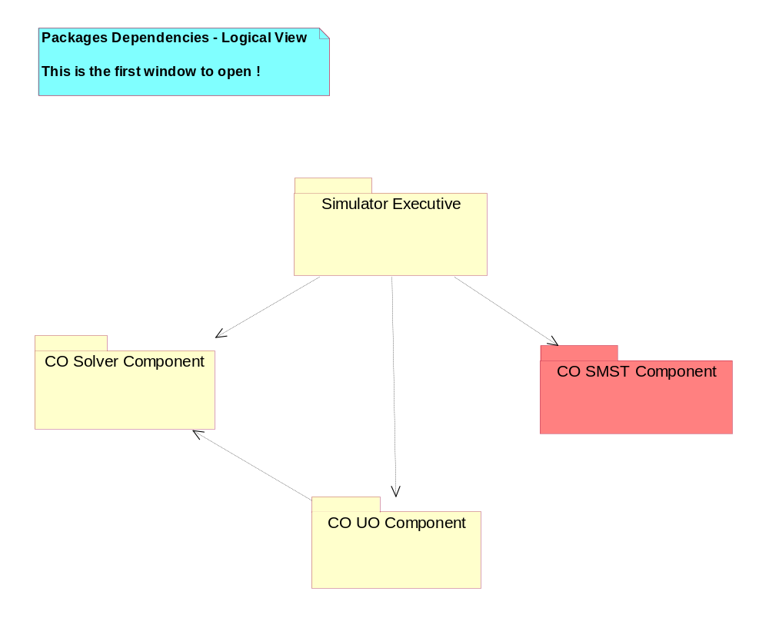
Figure 1. Packages Dependencies (Class Diagram)

CO SMST Component Logical Package
The package of CAPE-OPEN SMST Component.
It contains the CO SMST Specifications.

Diagram of CO SMST Component Package Class Diagram

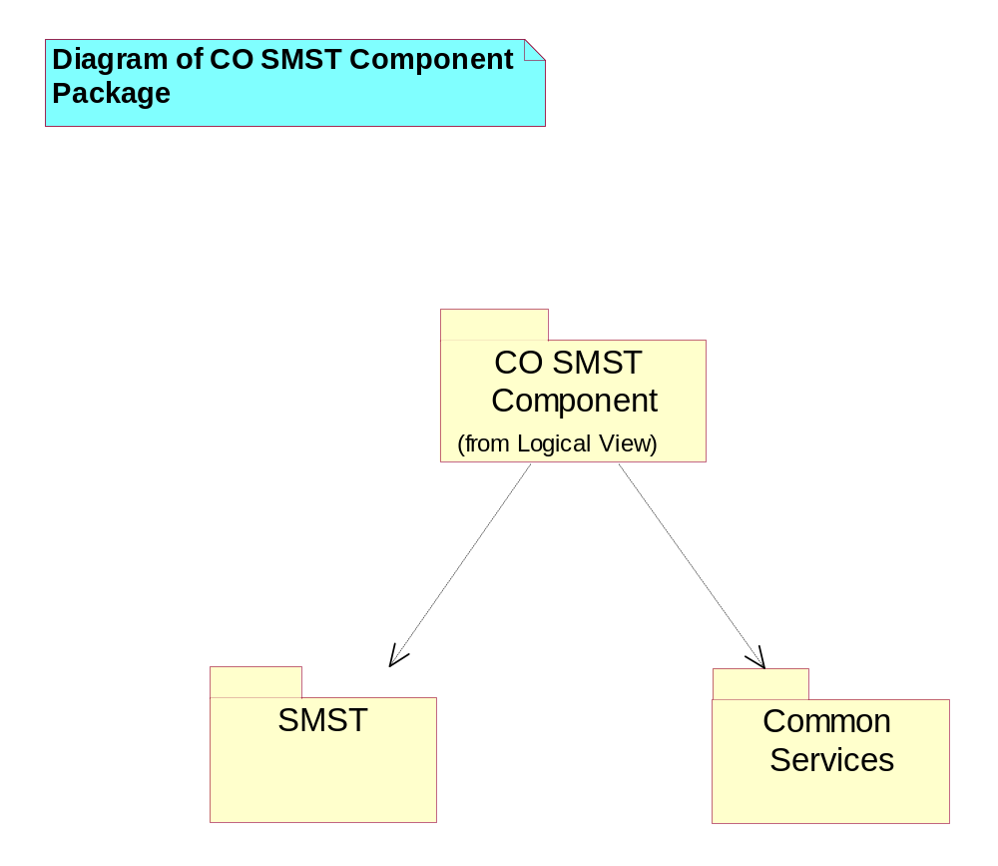
Figure 2. Diagram of CO SMST Component Package (Class Diagram)

Common Services Logical Package
The package of CAPE-OPEN Common Services.

Diagram of Common Services Package Class Diagram

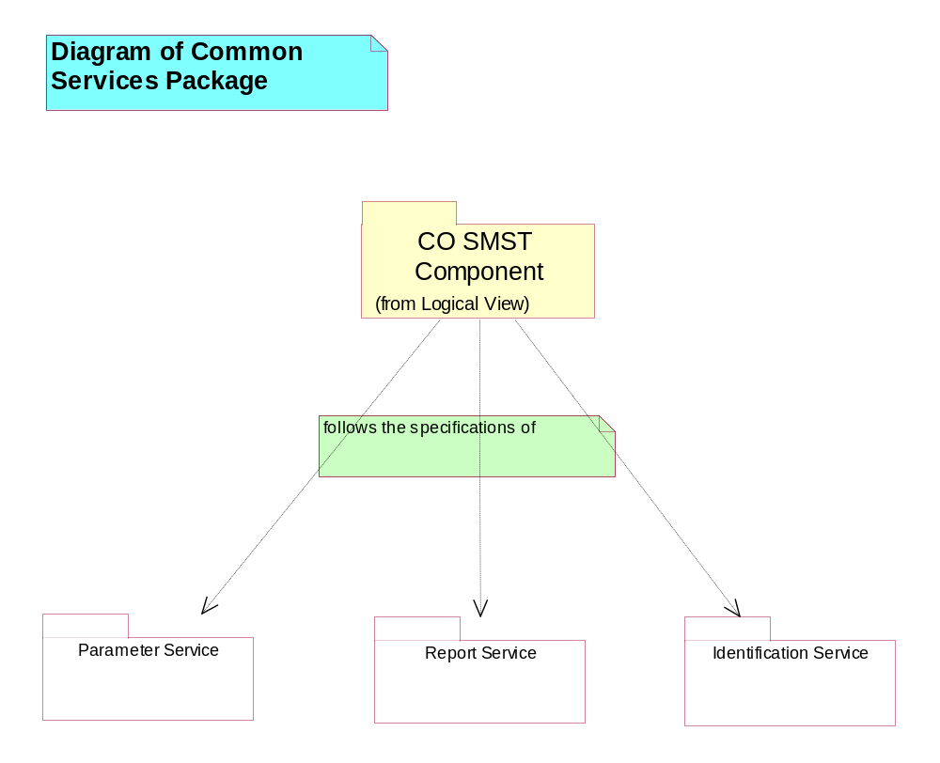
Figure 3. Diagram of Common Services Package (Class Diagram)

Identification Service Logical Package
The Package of Identification Service.
This Identification concept is a CAPE-OPEN Common Service. Its specification is not proposed here, refer to the CAPE-OPEN Concepts Document.
This package shows only how SMST integrates the Identification concept: the ICapeNumericGATComponent inherits from Identification interface.

Diagram of Identification Service Package Class Diagram

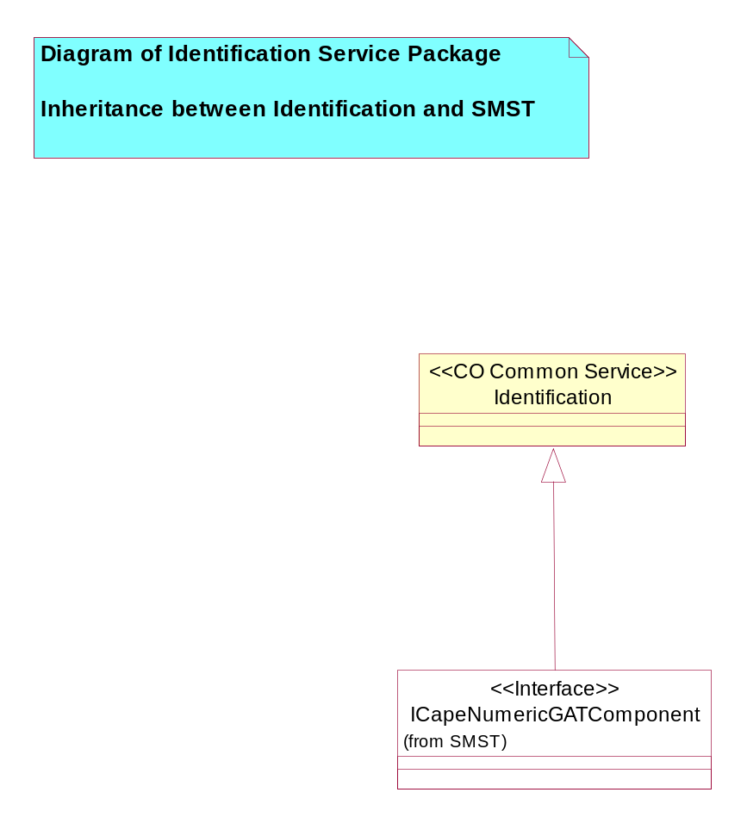
Figure 4. Diagram of Identification Service Package (Class Diagram)

Identification Class
Set of Interfaces including the Identification Concept.
It specifies the CAPE-OPEN common service on Identification concept.
No information on its content is given here, refer to the CAPE-OPEN Concepts Document.

Parameter Service Logical Package
The Package of Parameter Service.
This Parameter concept is a CAPE-OPEN Common Service. Its specification is not proposed here, refer to the CAPE-OPEN Concepts Document.
This package shows only how SMST integrates the Parameter concept: 4 SMST interfaces inherit from Parameter interface.

Diagram of Parameter Service Package Class Diagram

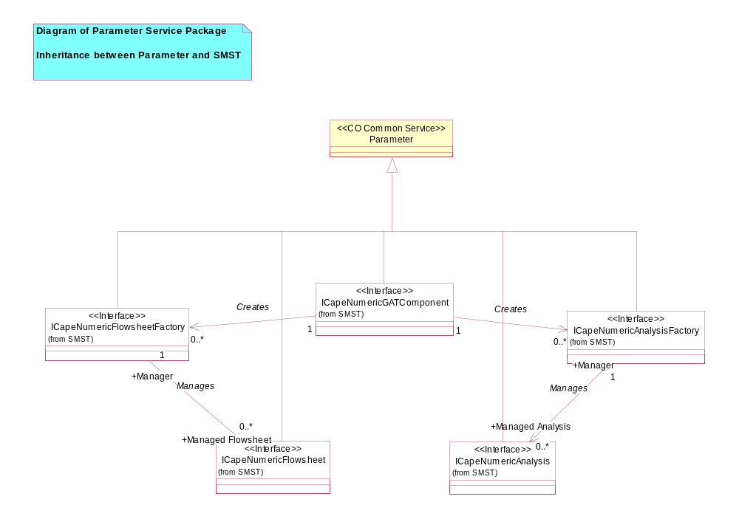
Figure 5. Diagram of Parameter Service Package (Class Diagram)

Parameter Class
Set of Interfaces including the Parameter Concept.
It specifies the CAPE-OPEN common services on the Parameter concept.
No information on its content is given here, please refer to the CAPE-OPEN Concepts Document.

Report Service Logical Package
The Package of Report Service.
This Report concept is a CAPE-OPEN Common Service. Its specification is not proposed here, refer to the CAPE-OPEN Concepts Document.
This package shows only how SMST integrates the Report concept: the ICapeNumericGATComponent inherits from Report interface.

Diagram of Report Service Package Class Diagram

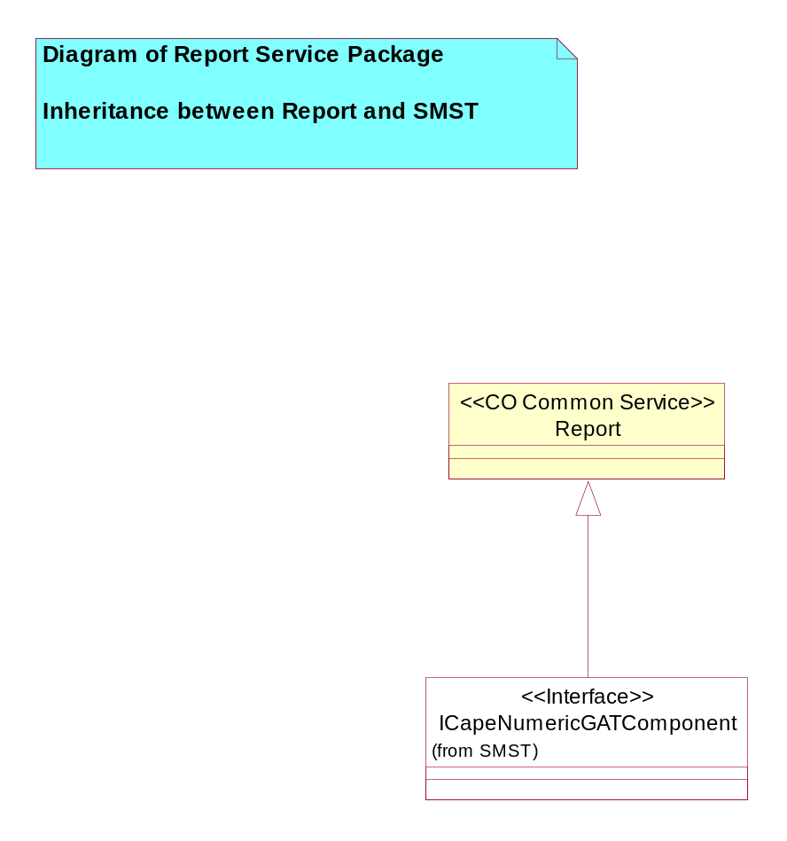
Figure 6. Diagram of Report Service Package (Class Diagram)

Report Class
Set of Interfaces including the Report Concept.
It specifies the CAPE-OPEN common service on Report concept.
No information on its content is given here, refer to the CAPE-OPEN Concepts Document.

SMST Logical Package
The Package of SMST.
It contains the specifications specific to the numerical flowsheet server.

Analysis Interface Diagram Class Diagram

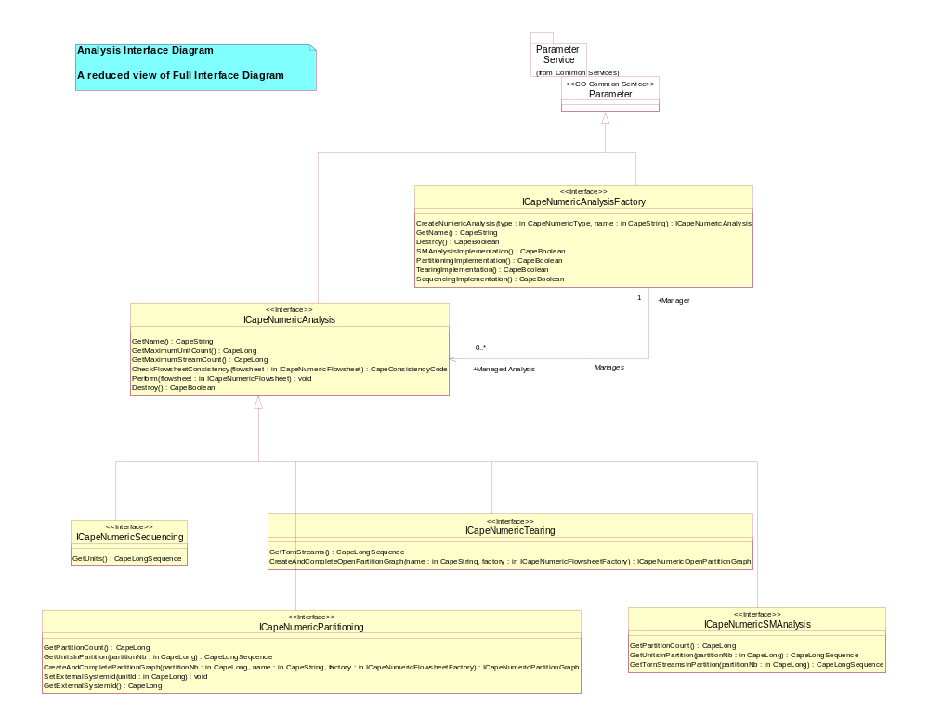
Figure 7. Analysis Interface Diagram (Class Diagram)

Flowsheet Interface Diagram Class Diagram

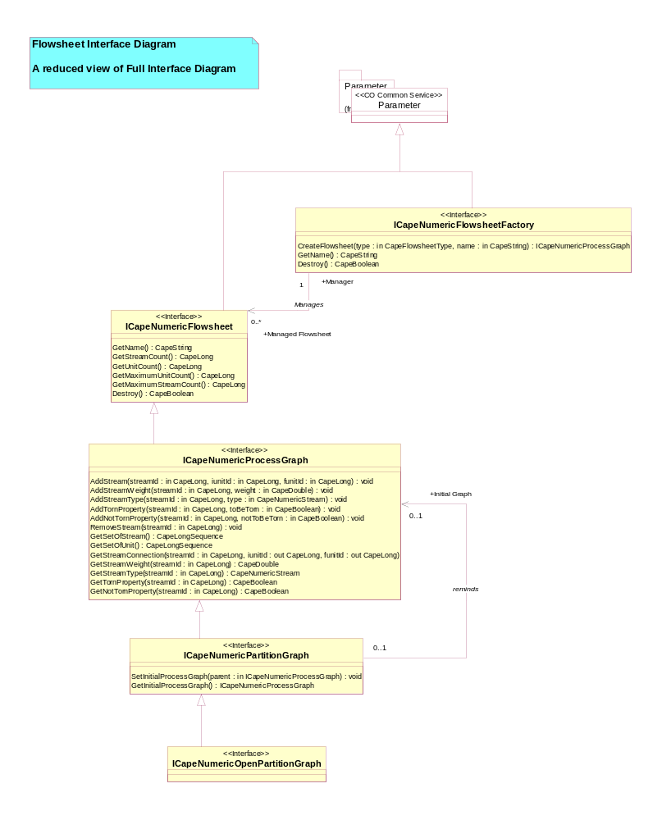
Figure 8. Flowsheet Interface Diagram (Class Diagram)

Full Interface Diagram Class Diagram

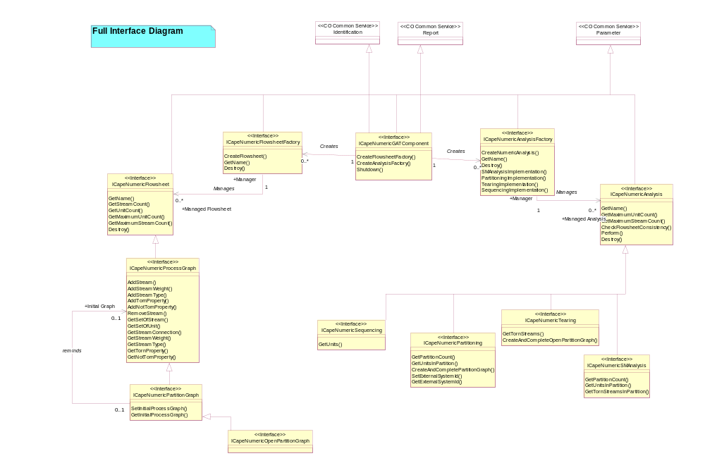
Figure 9. Full Interface Diagram (Class Diagram)

Manager Interface Diagram Class Diagram

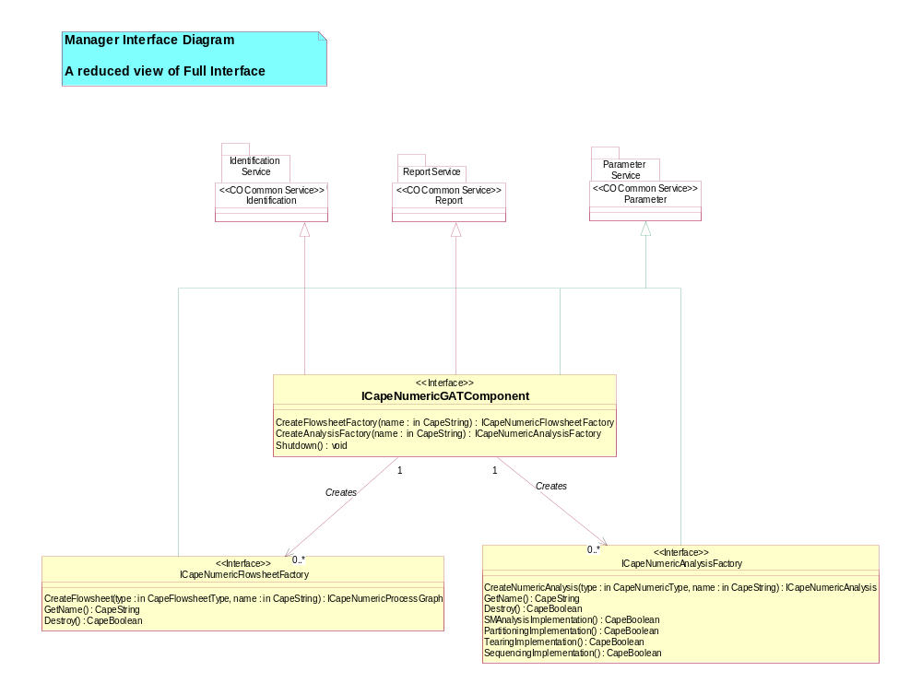
Figure 10. Manager Interface Diagram (Class Diagram)

ICapeNumericAnalysis Class
The ICapeNumericAnalysis Interface.
This is the basic Interface of numerical Analysis model: the minimum requirements for an analysis.
It is an "abstract" Interface. It is not distributed. So, no client can get its object reference.

CheckFlowsheetConsistency (flowsheet:in ICapeNumericFlowsheet) : CapeConsistencyCode

Destroy () : CapeBoolean

GetMaximumStreamCount () : CapeLong

GetMaximumUnitCount () : CapeLong

GetName () : CapeString

Perform (flowsheet:in ICapeNumericFlowsheet) : void

ICapeNumericAnalysisFactory Class
The ICapeNumericAnalysisFactory Interface.
This is the factory of a numerical Analysis.

CreateNumericAnalysis (type:in CapeNumericType, name:in CapeString) : ICapeNumericAnalysis

Destroy () : CapeBoolean

GetName () : CapeString

PartitioningImplementation () : CapeBoolean

SequencingImplementation () : CapeBoolean

SMAnalysisImplementation () : CapeBoolean

TearingImplementation () : CapeBoolean

ICapeNumericFlowsheet Class
The ICapeNumericFlowsheet Interface.
This is the basic Interface of Flowsheet description model. Would allow to develop a more complex Flowsheet description model.
It is an "abstract" Interface. It is not distributed. So, no client can get its object reference.

Destroy () : CapeBoolean

GetMaximumStreamCount () : CapeLong

GetMaximumUnitCount () : CapeLong

GetName () : CapeString

GetStreamCount () : CapeLong

GetUnitCount () : CapeLong

ICapeNumericFlowsheetFactory Class
The ICapeNumericFlowsheetFactory Interface.
This is the factory of a Flowsheet model.

CreateFlowsheet (type:in CapeFlowsheetType, name:in CapeString) : ICapeNumericProcessGraph

Destroy () : CapeBoolean

GetName () : CapeString

ICapeNumericGATComponent Class
The ICapeNumericGATComponent Interface.
This is the entrance object to the CO SMST Component.
First of all, the client must bind to this interface or get its reference by another way. Then, the client can access to the CO SMST Component.

CreateAnalysisFactory (name:in CapeString) : ICapeNumericAnalysisFactory

CreateFlowsheetFactory (name:in CapeString) : ICapeNumericFlowsheetFactory

Shutdown () : void

State Diagram:ICapeNumericGATComponent State Diagram

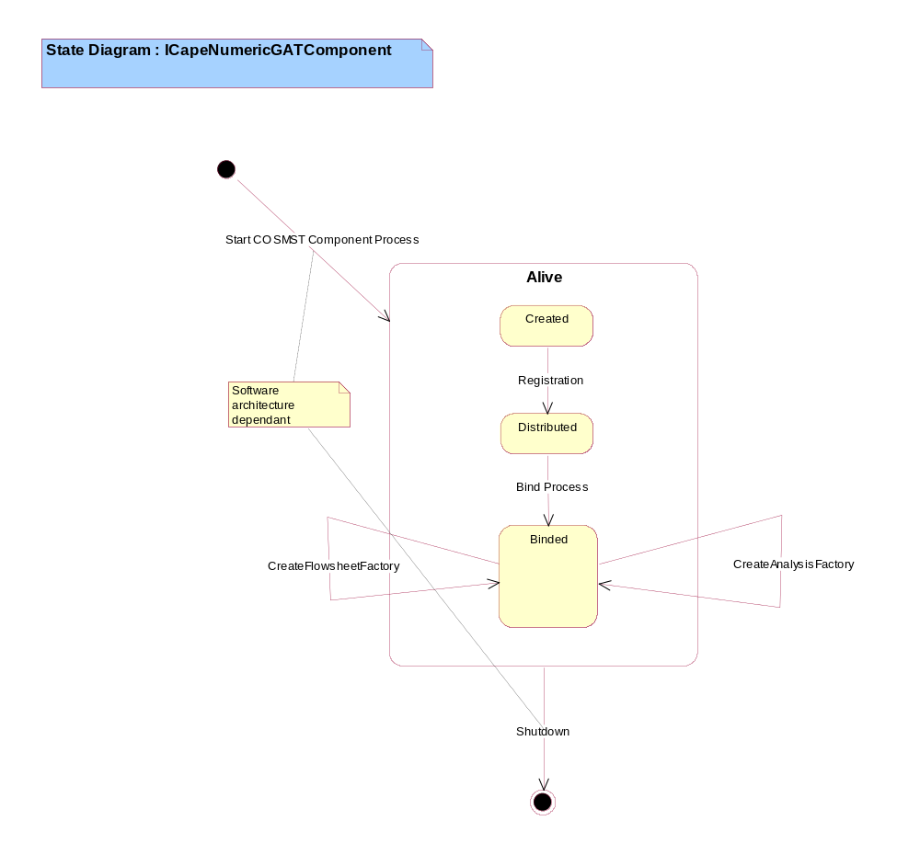
Figure 11. State Diagram:ICapeNumericGATComponent (State Diagram)

ICapeNumericOpenPartitionGraph Class
The ICapeNumericOpenPartitionGraph interface.
Use this to describe an Open Partition Graph.

ICapeNumericPartitionGraph Class
The ICapeNumericPartitionGraph interface.
Use this to describe a Partition Graph which is a Flowsheet having only one partition.

GetInitialProcessGraph () : ICapeNumericProcessGraph

SetInitialProcessGraph (parent:in ICapeNumericProcessGraph) : void

ICapeNumericPartitioning Class
The ICapeNumericPartitioning Interface.
Use this to perform a Partitioning Analysis on a Flowsheet.

CreateAndCompletePartitionGraph (partitionNb:in CapeLong, name:in CapeString, factory:in ICapeNumericFlowsheetFactory) : ICapeNumericPartitionGraph

GetExternalSystemId () : CapeLong

GetPartitionCount () : CapeLong

GetUnitsInPartition (partitionNb:in CapeLong) : CapeLongSequence

SetExternalSystemId (unitId:in CapeLong) : void

State Diagram:ICapeNumericPartitioning State Diagram

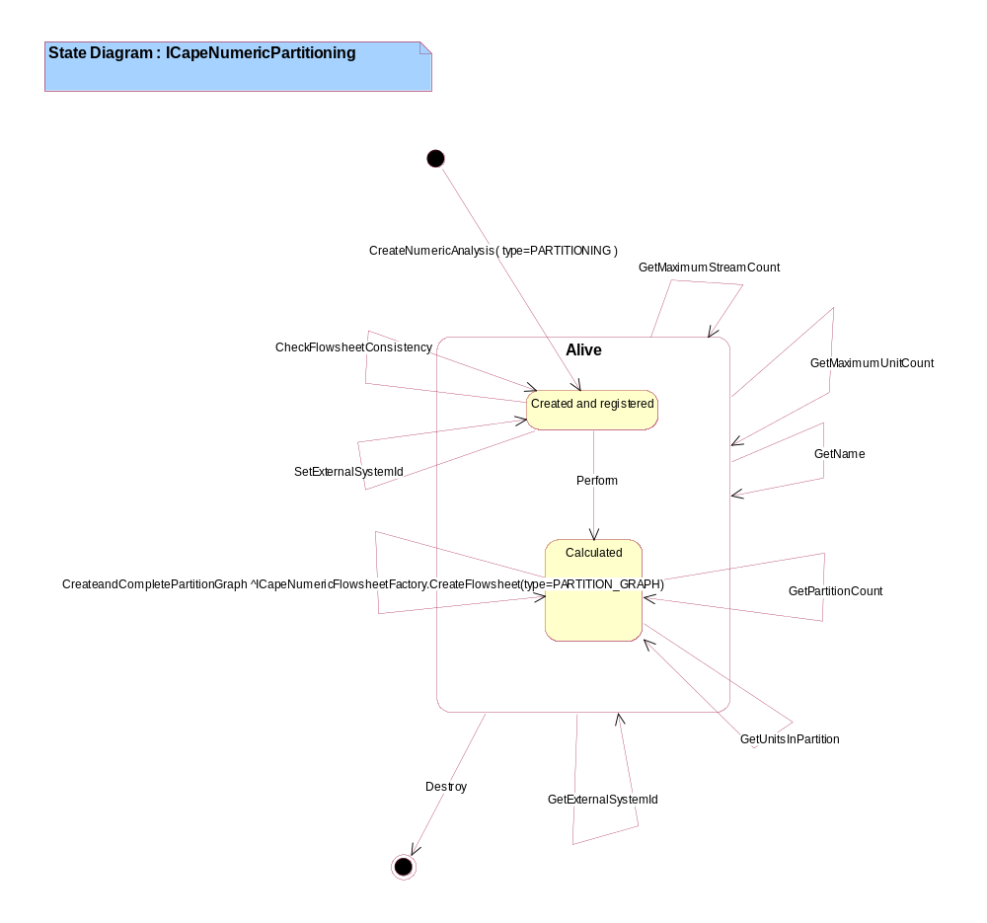
Figure 12. State Diagram:ICapeNumericPartitioning (State Diagram)

ICapeNumericProcessGraph Class
The ICapeNumericProcessGraph Interface.
Use this to describe a Process Graph which is any Flowsheet.

AddNotTornProperty (streamId:in CapeLong, notToBeTorn:in CapeBoolean) : void

AddStream (streamId:in CapeLong, iunitId:in CapeLong, funitId:in CapeLong) : void

AddStreamType (streamId:in CapeLong, type:in CapeNumericStream) : void

AddStreamWeight (streamId:in CapeLong, weight:in CapeDouble) : void

AddTornProperty (streamId:in CapeLong, toBeTorn:in CapeBoolean) : void

GetNotTornProperty (streamId:in CapeLong) : CapeBoolean

GetSetOfStream () : CapeLongSequence

GetSetOfUnit () : CapeLongSequence

GetStreamConnection (streamId:in CapeLong, iunitId:out CapeLong, funitId:out CapeLong) :

GetStreamType (streamId:in CapeLong) : CapeNumericStream

GetStreamWeight (streamId:in CapeLong) : CapeDouble

GetTornProperty (streamId:in CapeLong) : CapeBoolean

RemoveStream (streamId:in CapeLong) : void

State Diagram:ICapeNumericProcessGraph State Diagram

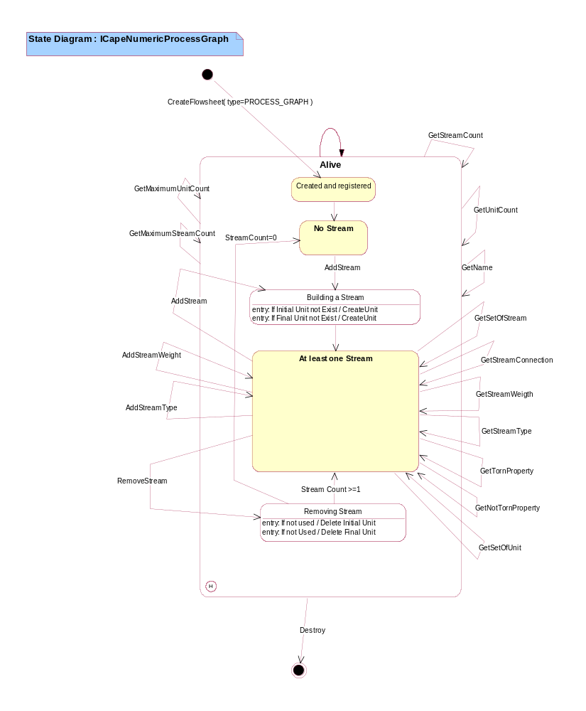
Figure 13. State Diagram:ICapeNumericProcessGraph (State Diagram)

ICapeNumericSequencing Class
The ICapeNumericSequencing Interface.
Use this to perform a Sequencing Analysis on a Flowsheet.
The flowsheet do not have any recycle.

GetUnits () : CapeLongSequence

State Diagram:ICapeNumericSequencing State Diagram

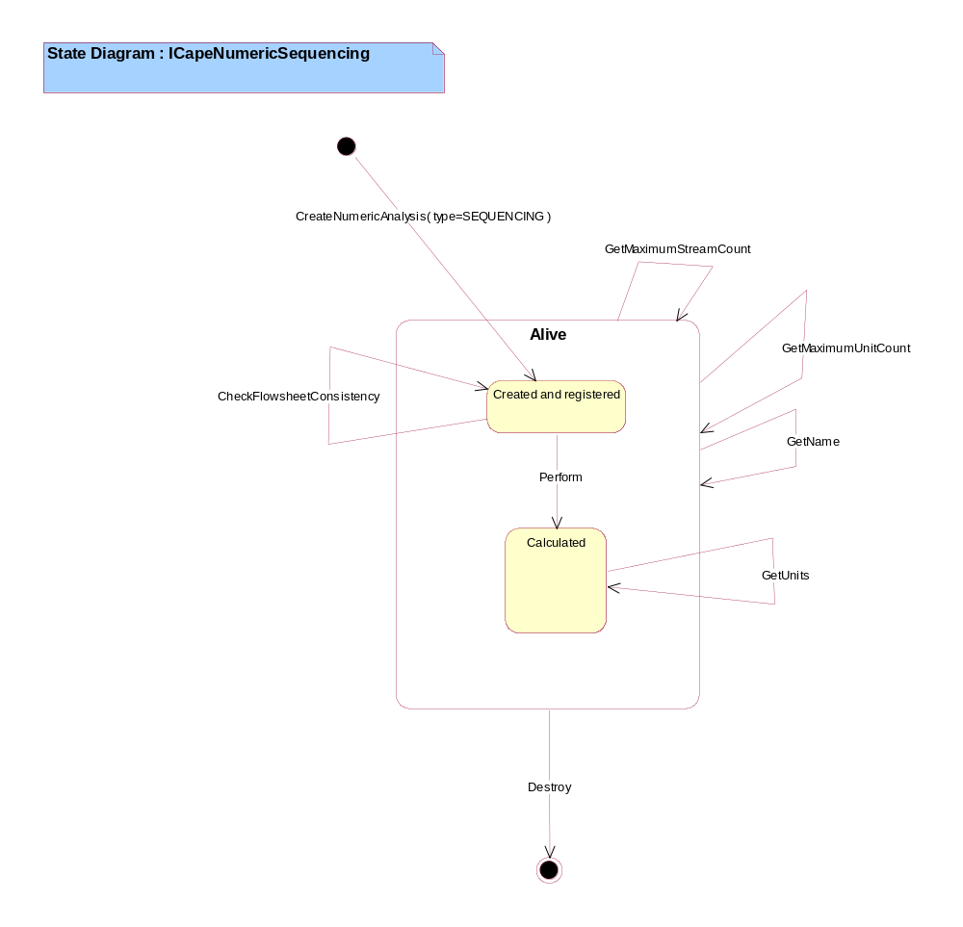
Figure 14. State Diagram:ICapeNumericSequencing (State Diagram)

ICapeNumericSMAnalysis Class
The ICapeNumericSMAnalysis Interface.
Use this to perform a Full Sequential Modular Analysis on a Flowsheet.

GetPartitionCount () : CapeLong

GetTornStreamsInPartition (partitionNb:in CapeLong) : CapeLongSequence

GetUnitsInPartition (partitionNb:in CapeLong) : CapeLongSequence

State Diagram:ICapeNumericSMAnalysis State Diagram

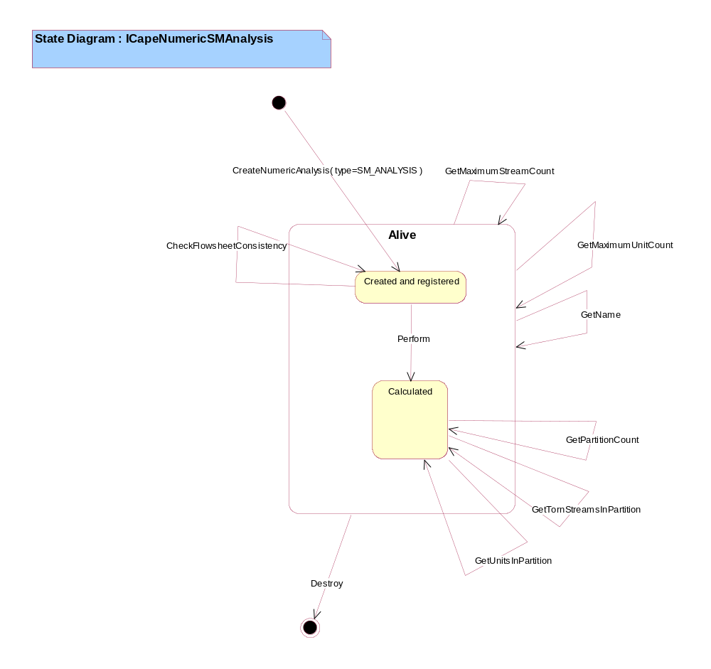
Figure 15. State Diagram:ICapeNumericSMAnalysis (State Diagram)

ICapeNumericTearing Class
The ICapeNumericTearing Interface.
Use this to perform a Tearing Analysis on a Flowsheet.

CreateAndCompleteOpenPartitionGraph (name:in CapeString, factory:in ICapeNumericFlowsheetFactory) : ICapeNumericOpenPartitionGraph

GetTornStreams () : CapeLongSequence

State Diagram:ICapeNumericTearing State Diagram

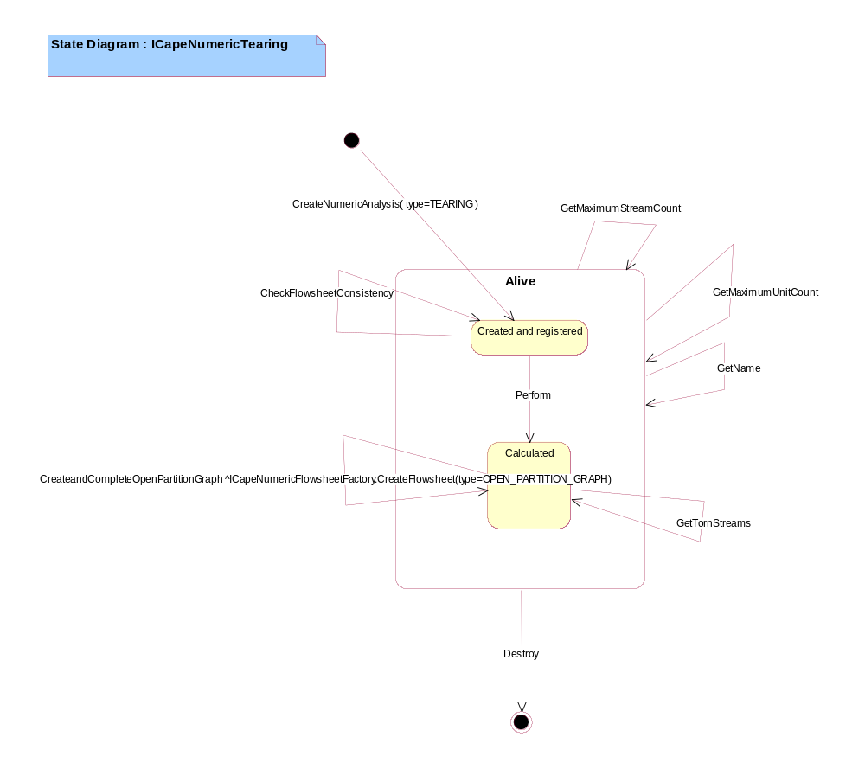
Figure 16. State Diagram:ICapeNumericTearing (State Diagram)

CO Solver Component Logical Package
The package of CAPE-OPEN Numerical Solver Component.
Refer to the Software Component Documentation of Numerical Solvers.

CO UO Component Logical Package
The package of CAPE-OPEN Unit Operation Component.
Refer to the Software Component Documentation of Unit Operations.

Simulator Executive Logical Package
The package of a CAPE Simulator Executive.

Diagram of Simulator Executive Package Class Diagram

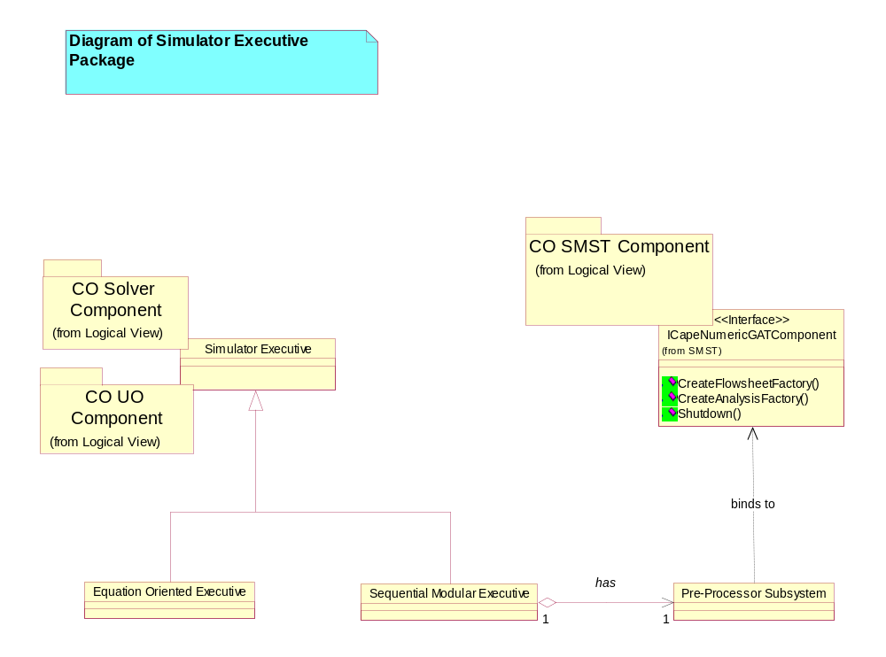
Figure 17. Diagram of Simulator Executive Package (Class Diagram)

Equation Oriented Executive Class
Simulator Executive using Equation Oriented solving.

Pre-Processor Subsystem Class
It is the pre-processor part of a CAPE simulator.
It uses the CAPE-OPEN SMST Component.

Sequential Modular Executive Class
Simulator Executive using Sequential Modular solving.

Simulator Executive Class
That part of a simulator whose job it is to create or load a previously stored flowsheet, solve it and display the results.

